Thiamine-Mediated Benzoin Condensation of Furfural

**Reference:** Handout; Chemistry lessons: Carbonyl chemistry, oxidation chemistry, carbon skeleton rearrangements; Green lessons: safer and easier to handle reagents and solvents; Bruice pg. 752-753

**Purpose:** To explore how thiamine affects the formation of furoin from furfural through benzoin condensation reactions

**Table of Reagents:**

|  |  |  |  |  |  |
| --- | --- | --- | --- | --- | --- |
| **Compounds** | **MW** | **Amount** | **BP (°C)** | **MP (°C)** | **Density** |
| Thiamine HCl | 337.26 g/mol | 0.3 g | - | 250 °C | - |
| Ethanol (EtOH) | 46.07 g/mol | 3 mL | 78.37 °C | -114.1 °C | 0.789 g/cm3 |
| Water (H2O) | 18.01 g/mol | - | 100 °C | 0 °C | 1.00 g/cm3 |
| NaOH | 39.997 g/mol | 8.0 g | 1388 °C | 318 °C | 2.13 g/cm3 |
| Furfural | 96.08 g/mol | 0.73 mL | 162 °C | -37 °C | 1.16 g/cm3 |

**Balanced Chemical Equation:**

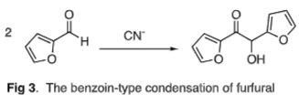

**Mechanism:**

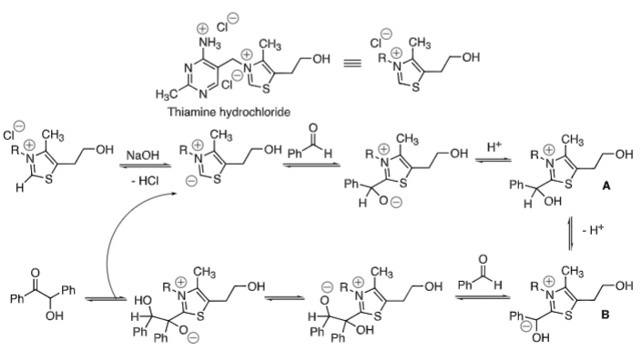

**Safety:**

* Furfural 🡪 toxic; Handle with care
* Sodium Hydroxide 🡪 irritant; Avoid skin & eyes

|  |  |
| --- | --- |
| **Experimental Procedures** | **Data & Observations** |
| **Part I: Reaction**  **1.** Obtain 25 mL round-bottom flask; add stir bar & 0.3 g thiamine HCl in mixture with 0.45 mL water/ 3.0 mL of EtOH   * Mixture should be clear/colorless |  |
| **2.** Dropwise 🡪 add 0.9 mL of solution with 8 g of NaOH in 100 mL of water (already provided)   * Continue to add NaOH until reaction is pale-yellow; if not, add more NaOH | *Observations:* Mixture started to turn pale yellow |
| **3.** Add 0.73 mL of furfural & mix; store in drawer until next lab   * BE SURE TO SEAL THE FLASK!!! |  |
| **Part II: Workup and Purification**  **4.** Cool mixture in ice bath; Add water to cooled mixture to drive remainder of product; Isolate using vacuum filtration   * Record mass of product |  |
| **5.** Recrystallize product using the EtOH |  |
| **Part III: Characterization**  **6.** Record yield, melting point, and IR spectrum of the furion | *True Melting Point:* 135 °C – 137 °C  *Product Melting Point:* 137 °C  *Product Mass:* 0.58 g |

**Post-lab Questions:**

**1. a)** We collected 2.3961 g of the crude product as well as the color of our product was styrofoam-white.

$$\% Yield= \frac{Product Obtained}{Theoretical Yield}×100$$

*Obtained:* 2.3961 g *Color and State:* Styrofoam-White

* First, we must obtain the theoretical value of our crude product in grams:
$$2.4973 g Vanillin×\frac{1 mol Vanillin}{152.15 g Vanillin}×\frac{4 mol Product}{4 mol Vanillin}×\frac{154.16 g Product}{1 mol Product}=2.5303 g Vanillyl Alcohol$$

* Next, we must use the equation above to get our % Yield:
$$\% Yield=\frac{2.3961 g}{2.5303 g}×100=94.7\% yield$$

* *We received a 94.7% yield for our product*
* *We received a high percent yield!!!*

**b)** Our crude product melted at 98 °C, which concludes that it contains impurites as it has experienced melting point depression. The true melting point range of the pure product was recorded to be between 110 – 117 °C, whereas our product melted below the range. On the same note, this proves that our product’s crystalline structure was disrupted by impuritues, which lowered our thought to be pure product’s melting point. In addition, some of the reageants might not have fully reacted such as the vanillin, which might have resulted in the lower melting point.

**2.**